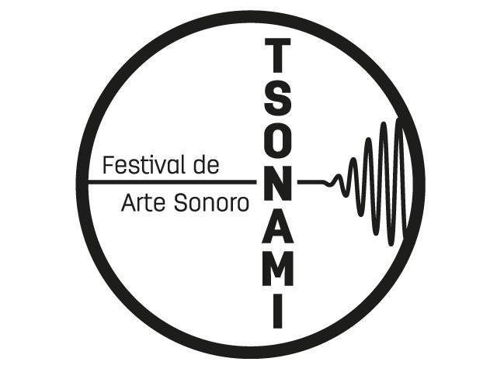

Place, Listening & Record
Open Call for Residencies
Tsonami Sound Art Festival 2013

Application Form

Project:
Brief description of the proposal to research/develop (400 words max.)

Personal Information:
Complete Name:
Artistic Name (in case it exists):
Adress and City:
Country:
Telephone:
E-mail:
Website:
Brief Biography:
Attach a complete dossier with previous works:

The proposals must be sent to the following email: artesonoro@tsonami.cl.

The closing date for applications will be on September 15, 2013 at 22:00 hours continental Chile time.

